Year | Total no of related activities
2020-21 | 51

DETAILED REPORT
3.4.3 NUMBER OF EXTENSION AND OUTREACH PROGRAMS CONDUCTED BY THE INSTITUTION THROUGH NSS/ NCC/ GOVERNMENT AND GOVERNMENT RECOGNISED BODIES DURING THE YEAR

S.No | Activity | Date | Report of the Event | Photo
1 | Online Quiz in order to pay tribute to Kargil war heroes on the occasion of Kargil Vijay Diwas.  Name - Online Quiz on Kargil Vijay Diwas  Collaborating agency - NCC | Wednesday, 29 July 2020 | The NCC Unit of the college organised an Online Quiz in order to pay tribute to Kargil war heroes on the occasion of Kargil Vijay Diwas. The quiz included 20 multiple type questions on Kargil war. This online quiz link was open for participants from 9 am to 5 pm. Such a unique quiz competition will inculcate the feeling of patriotism in young brigade. Total of 1121 students participated in this quiz from all over India. E-certificates were provided to all the participants. | 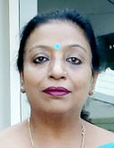  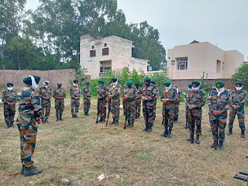
2 | Online quiz competition dedicated to the life, gurbani, martyrdom and teachings of Shri Guru Teg Bahadur ji on the occasion of 400th birth anniversary  Name - Online Quiz competition on Shri Guru Teg Bahadur ji  Collaborating agency – NCC & NSS | Wednesday, 12 August 2020 | The NSS unit of the college organized online quiz competition dedicated to the life, gurbani, matrydom and teachings of Shri Guru Teg Bahadur ji on the occasion of 400th birth anniversary of Guru ji. Around 259 students participated in quiz competition enthusiastically. 68 students got A grade, 53 students got B grade and 72 students got C grade. | 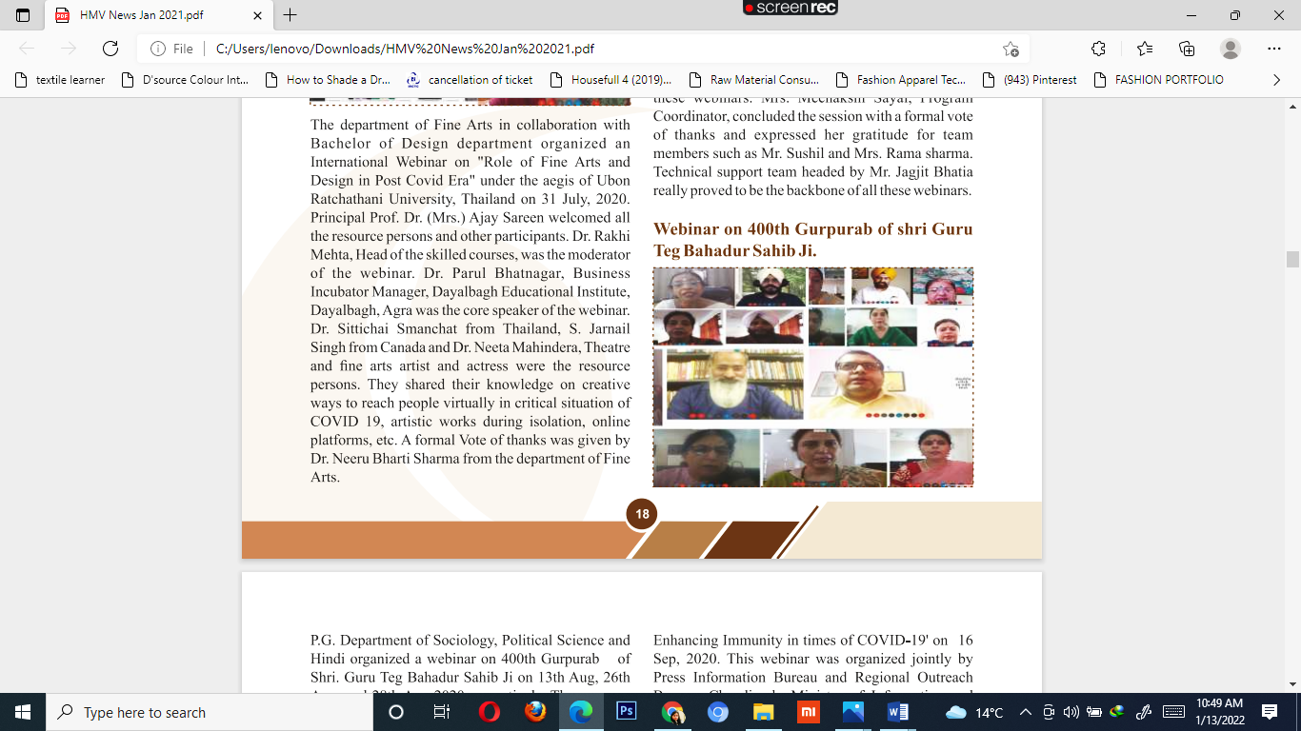
3 | Fit India Freedom Run Program of Youth  Name - Fit India Freedom Run  Collaborating agency – Youth and Sports Ministry, Government of India | Friday, 28 August 2020 | The NSS unit and Sports Department of the college participated in Fit India Freedom Run Program of Youth and Sports Ministry, Government of India. This program was organized till 2nd October. The NSS volunteers enthusiastically participated in this program. On the first day of the program, they were told about the importance of exercise and yoga in order to have a balanced and healthy body. The participant students were also encouraged to tell their neighbors and relatives about the importance of yoga in this stressful time of COVID. This campaign helped in increasing the immunity, changing lifestyle of the people and also helped them in living a healthy life in pandemic times. | 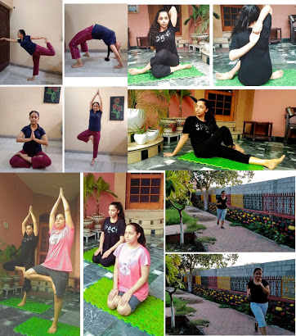
4 | Fit India Freedom Run campaign of Youth and Sports Ministry, Government of India  Name - Fit India Freedom Run campaign  Collaborating agency – Youth and Sports Ministry, Government of India | Tuesday, 8 September 2020 | The NSS, NCC and Sports Departments of the college participated in Fit India Freedom Run campaign of Youth and Sports Ministry, Government of India. Under this campaign, the participants made the people of their neighborhood aware about the importance of doing exercise, eating balanced nutritious diet and having a positive attitude in these pandemic times. Participants followed the rules of social distancing, wore masks and used sanitizers. During this campaign, the NCC cadets participated in a 24 km run. | 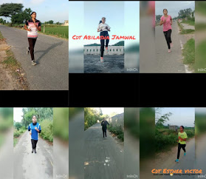
5 | NCC cadets of 2 PB(G) BN NCC Jalandhar participated in second phase of ‘Fit India Movement’  Name - Second phase of ‘Fit India Movement’  Collaborating agency – Youth and Sports Ministry, Government of India | Sunday, 20 September 2020 | The NCC cadets of the college of 2 PB(G) BN NCC Jalandhar participated in second phase of ‘Fit India Movement’. The cadets did different exercises and ran 20 kms to keep themselves both physically and mentally fit under the commanding officer Col. NPS Toor. 10 cadets performed exercises while staying at home and each cadet did running of 2 km each and shared the details and pics through online mode. On this occasion, Col. NPS Toor inspired the cadets to remain physically and mentally fit especially in this pandemic because if they will remain fit only then they can serve the nation and society in a better way. | 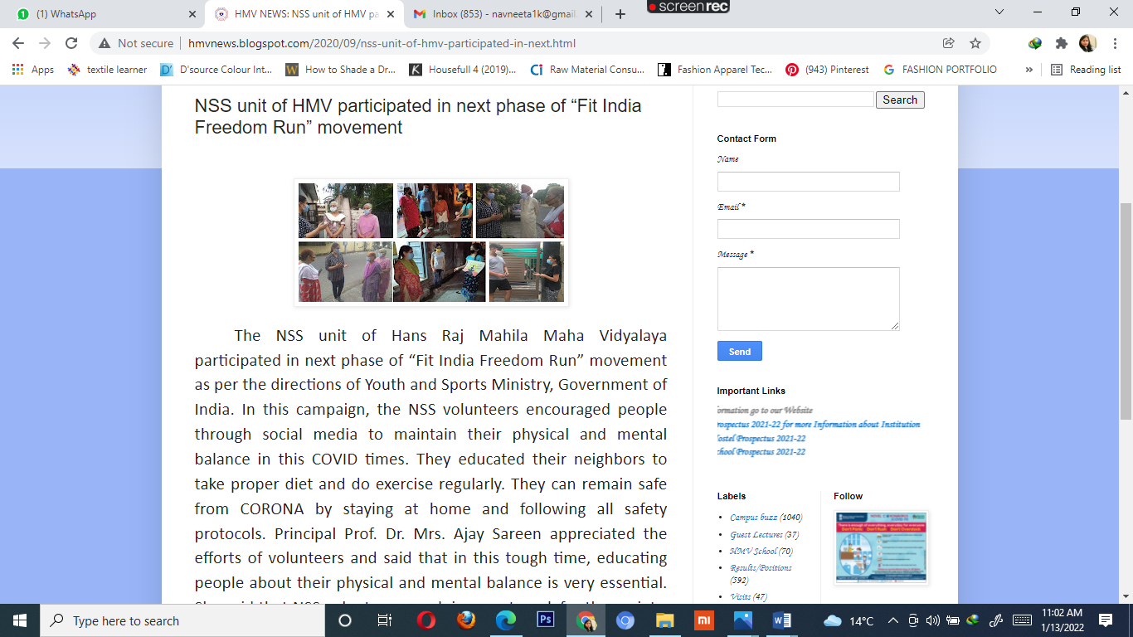
6 | NSS Volunteers watched the award ceremony through virtual medium which was held at Rashtrapati Bhawan, New Delhi  Name - Award Ceremony at  Rashtrapati Bhawan,  Collaborating agency – NSS | Saturday, 26 September 2020 | The NSS Volunteers of the college watched the award ceremony through virtual medium which was held at Rashtrapati Bhawan, New Delhi as per the direction of Govt. of India. In this award ceremony, President of India Sh. Ram Nath Kovind honored NSS volunteers for their commendable work. This programme was watched by NSS Volunteers of HMV while stayinig at home as per the directions of Government of India. NSS Programme Officers conveyed the volunteers about the programme in advance so that they can watch it timely and feel motivated. | 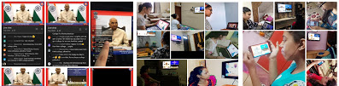
7 | “Trash to Treasure” “My waste my responsibility” campaign  Name - Trash to Treasure  Collaborating agency – Municipal Corporation, Jalandhar | Wednesday, 30 September 2020 | The NSS Volunteers of the college participated in “Trash to Treasure” “My waste my responsibility” campaign. This campaign is being organised by Municipal Corporation, Jalandhar from 22nd September to 15 October, 2020. It is a matter of pride for HMV that many volunteers have participated in this campaign. The motive of this campaign was to encourage society that it is our prime duty to clean our surroundings. We should understand our responsibility and contribute whole heartedly in this campaign. Km. Ishpreet Kaur made a beautiful doll with waste newspapers. Km. Harmanpreet Kaur also made decorative pieces with waste material. | 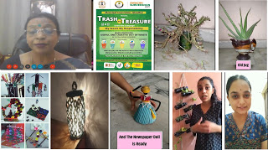  
8 | 'My Waste My Responsibility'  Name - My Waste My Responsibility  Collaborating agency – Municipal Corporation, Jalandhar | Thursday, 15 October 2020 | College was appreciated by Municipal Corporation Jalandhar for contribution in 'My Waste My Responsibility' campaign. Ms. Gurkirat was chosen as Swachhta Ambassador of Jalandhar with first prize by Municipal Corporation in jingle competition. Ms. Navjot who sang Swachhta Jugni has also been chosen at third place. Ms. Sargam, Ms. Harman, Ms. Ishpreet and Ms. Ridhi were honoured for their contribution in trash to treasure campaign. They prepared creative decorative pieces, beautiful cots, newspaper dolls, planters etc. One student from school section, Ms. Megha was honoured for making scenery from newspaper. Lord Krishna's bed made by Ridhi was appreciated by one and all. Dr Anjana Bhatia also received the honour for her contribution. | 
9 | A workshop on Swacchta in collaboration with Ministry of Human Resource Development, Government of India  Name - Swacchta  Collaborating agency – Ministry of Human Resource Development, Government of India | Saturday, 24 October 2020 | The NSS unit of the college organised a workshop on Swacchta in collaboration with Ministry of Human Resource Development, Government of India. The main objective of this workshop was to make the students aware and educate about swacchta. The chief guest of the workshop was Joint Commissioner, Municipal Coroporation, Jalandhar, Ms. Inayat (PCS) and main speaker was Dr. Rajni (Mahatma Gandhi National Council Rural Education, Government of India). The students prepare beautiful bags with this recycled paper made by recycling machine installed in premises of HMV. The college also prepares compost with dried leaves, give planters as gifts and celebrating green diwali are regular features at the college. Chief Guest Ms. Inayat (Joint Commissioner) said that swacchta is responsibility of not only government but it is the responsibility of every citizen. Each one of us will have to contribute in this campaign only then we can make a swacch and beautiful society. | 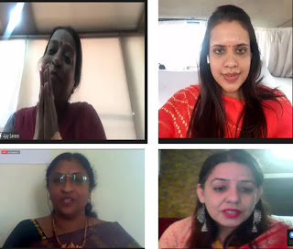
10 | Pledge Ceremony under Jan Andolan Campaign of Govt. of India.  Name - Pledge Ceremony  Collaborating agency –NSS and Government of India | Friday, 30 October 2020 | The NSS department of the college organized a Pledge Ceremony under Jan Andolan Campaign of Govt. of India. In this programme, NSS programme officer facilitated a pledge to faculty, staff members and students to follow the unlock guidelines. This campaign was launched by Honorable Prime Minister Sh. Narendra Modi. Principal of the college said that cases of Corona have decreased but the danger is still there. Government is trying to aware people through media regarding unlock guidelines. We are getting some relief during unlock but that is for strengthening our economy. We should take proper precautions. HMV has taken a lead in becoming a part of this campaign. We should not panic if any symptom of Corona occurs. Rather we should go for test and medication. The time of Corona was really tough for all of us but we have crossed it with our positivity. | 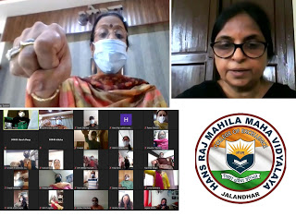
11 | Plantation Diver  Name - Plantation Diver  Collaborating agency –NSS and Government of India | Thursday, 29 October 2020 | Plantation of Parijat tree was done near the Yajnashala in the premises of Hans Raj Mahila Maha Vidyalaya. Jalandhar. The plantation was done to spread the message of water conservation. During the plantation, Parijat tree, also called the Kalpavriksh was planted along with a traditional unglazened Matka filled with water. The water oozing out from the pot can be enough for one week. Such method conserves water and uses drip irrigation technique to water the plants. On this occasion, ornamental plants were also planted in the campus under the aegis of PG Department of Botany. | 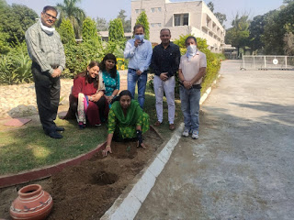
12 | One month long NCC Republic Day Camp  Name - NCC Republic Day Camp  Collaborating agency – NCC | Tuesday, 27 October 2020 | The college has been chosen by NCC group headquarters for organizing one month long NCC Republic Day Camp. ThE CAMP was in premises of HMV under the aegis of Brig. Advitya Madan. He told that total 25 cadets have been selected and after undergoing training for Drill, Firing, Best Cadets for ANO’s, JCO’s, NCO’s will be selected. Cadets for various institutes of Kapurthala, Hoshiarpur, Phagwara, Jalandhar are participating in the camp. Training time is from 08.30 hr to 16.00 hr. Best cadets are receiving training in group discussion, lecturettes, drill, firing & specialized subjects. These cadets once selected will participate in the Youth Exchange Programme with friendly foreign countries. | 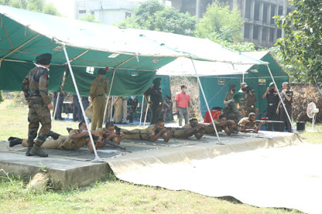
13 | Students conducted the stage during the virtual inauguration  Name - Virtual inauguration by Chief Minister of Punjab  Capt. Amrinder Singh  Collaborating agency – Municipal Corporation | Sunday, 8 November 2020 | The students of the college conducted the stage during the virtual inauguration done by Chief Minister of Punjab Capt. Amrinder Singh. Taking in consideration COVID 19 Jalandhar Municipal Corporation organized the live broadcasting of this ceremony through LED screen at 14 various places of Jalandhar namely Shri Ram Chowk, Company Bagh, Model House, Urban Estate Phase I, PPR Mall, 120 ft Road, Shri Jagjiwan Ram Chowk, Mata Rani Chowk (Model House), Baba Budha Ji Puli, Kapurthala Road, Bhagat Singh Chowk, Sodal Chowk, Maqsudan Chowk, Bus Stand, Garha Road, DC Complex Near Fire Office and Kaki Pind. The students of Hans Raj Mahila Maha Vidyalaya conducted the stage at these places and told people about all the new projects. These students were Gurkirat Kaur, Ishpreet Kaur, Surbhi Sharma, Mansi Lachotra, Jagjit Kaur, Gurwinder Kaur, Navjot Kaur, Riya, Divyjot Kaur, Ridham, Sakshi, Gagandeep and Lisha Juneja. | 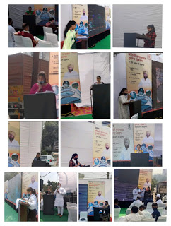
14 | NSS volunteer has been selected for Pre-Republic Day Camp  Name - Pre-Republic Day Camp  Collaborating agency –  NSS | Wednesday, 25 November 2020 | It is matter of great pride that NSS volunteer of the college has been selected for Pre-Republic Day Camp. She is pursuing B.A. Sem-V at HMV. Km. Raunika and said that it is a matter of honour for the institution that our student has been selected for Republic Day Parade. She told that this selection camp was organized on 17th November, 2020 at Lovely Professional University in which almost 38 students from different institutions participated. The candidates had undergone a selection process which included Parade, Running and Interview. Ms. Raunika cleared all the stages of selection process and got selected. | 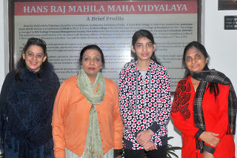
15 | 8 Cadets of Army Wing with incentives for performing duties on ground during Exercise NCC Yogdan for fighting against COVID-19  Name - NCC Yogdan  Collaborating agency –  NSS | Thursday, 19 November 2020 | It is a matter of pride that Commanding Officer Col. NPS Toor of 2 Punjab Girls BN NCC Jalandhar honoured ANO Lt. Sonia Mahindru and 8 Cadets of Army Wing of the college with incentives for performing duties on ground during Exercise NCC Yogdan for fighting against COVID-19. On this occasion Commanding Officer Col. Hitesh Duggal of 21 Bn Kapurthala was also present who greatly appreciated the tasks performed by cadets during peak days of COVID pandemic. Ms Parvati GCI from 2Pb (G) BN congratulated cadets and motivated them for such tasks in future. | 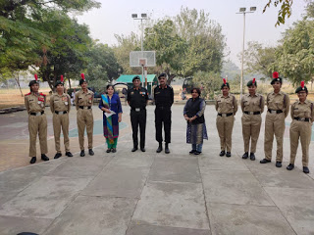
16 | Essay Writing and Painting Competitions during Communal Harmony Campaign Week  Name –  Communal Harmony Campaign Week  Collaborating agency –  NSS | Friday, 4 December 2020 | The NSS of the college observed “Communal Harmony Campaign Week” as per the guidelines of National Foundation for Communal Harmony, Home Ministry, Govt. of India, NSS Volunteers participated in various competitions during this week long observance and expressed their views on it. On this occasion, Essay Writing and Painting Competitions were organized on the topic “Communal Harmony”. In Essay Writing Competition Km. Manpreet stood 1st, Km. Khushdeep Kaur stood 2nd & Km. Priya Sharma stood 3rd. In Painting Competition, Km. Akshreeti got 1st, Km. Sumandeep got 2nd, Km. Garima & Km. Neha Luthra got 3rd Prize.Flag stickers were also distributed among volunteers. | 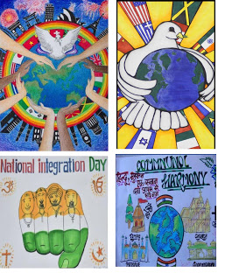
17 | Neki Ki Deewar – wall Inaugration  Name –  Neki Ki Deewar  Collaborating agency –  NSS | Tuesday, 15 December 2020 | The name of HMV has been synonymous with setting novel trends and undertaking & campaigns for social welfare. Marching forward with its noble mission, ‘Neki Ki Deewar’ was inaugurated. The wall was inaugurated by Sh. Avtar Singh Junior (Bawa Henry), MLA, Sh. Mohinder Singh Gullu, Councillor and Sh. Manbir Singh. This wall is an initiative undertaken under the canopy of Mahatma Hans Raj Samvedna Samiti. It was appealed to all to donate generously and help the poor people in the cold weather. People can donate the things which remain unused and thus help those who are in need of them. The Chief Guest Sh. Avtar Singh Junior lauded the efforts of the institution and said that, these efforts make our living worthwhile. It is the biggest service to mankind as it is selfless and the path is already shown to us by our gurus. He also urged to sustain and maintain this project so that it keep on running continuously and set an example for others to follow. | 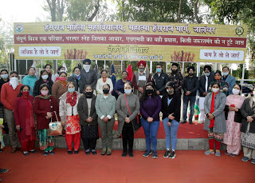
18 | Fit India Prabhat Pheri under Fit India Campaign  Name –  Fit India Prabhat Pheri  Collaborating agency –  NSS | Friday, 11 December 2020 | The NSS Volunteers of the college organized Fit India Prabhat Pheri under Fit India Campaign, for the success of this campaign, the volunteers organized Prabhat Pheris alongwith their neighbourers. The message of this campaign is a healthy mind develops in healthy body. All the young volunteers are full of enthusiasm and energy and working for the development of society and country. Our country needs dedicated and loyal volunteers like you. NSS not only developes your character but also gives you a sense of discipline, working in coordination and helps you to identify your strength & weaknesses. | 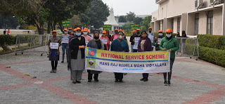  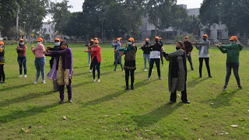
19 | Plogging event to celebrate Swachhta Pakhwada  Name –  Swachhta Pakhwada  Collaborating agency –  NSS and NCC | Sunday, 10 January 2021 | NCC unit of the college under 2PB (G) BN NCC Jalandhar, PHHPC Directorate organized Plogging event to celebrate Swachhta Pakhwada as per guidelines received from DGNCC, following all protocols of COVID- 19. Total 35 cadets of Army and Air Wing along with ANO Lt Sonia Mahindru (Army wing) and CTO Mrs Purnima (Air Wing) participated in the activity. Cadets jogged around the HMV campus and picked the trash to keep the surroundings clean. | 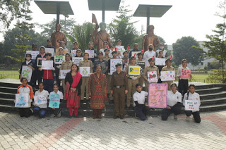
20 | Celebrated Lohri with Ex-servicemen Welfare Association Bhogpur (District Jalandhar)  Name –  Lohri Celebrations  Collaborating agency –  NSS & NCC | Friday, 15 January 2021 | The NSS Volunteers of the college celebrated Lohri in association with Ex-servicemen Welfare Association Bhogpur (District Jalandhar) . This association is run by Additional Deputy Commissioner Sh. Jasbir Singh (PCS) in order to enhance the skill and personality of the girls in the adjoining areas. The volunteers performed cultural activities in the event. | 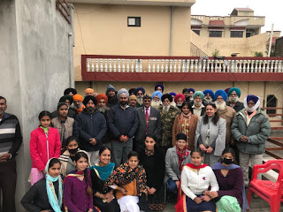
21 | National Voters’ Day  Name –  National Voters’ Day  Collaborating agency –  District Election Office | Monday, 25 January 2021 | College has successfully hosted the National Voters’ Day in association with District Election Office. The event witnessed the presence of Deputy Commissioner Sh. Ghanshyam Thori, IAS Jalandhar as the Chief Guest, accompanied by ADEO, Additional Deputy Commissioner Sh. Vishesh Sarangal,IAS, Dr. Sanjeev Sharma (PCS, SDM Shahkot), Sh. Jasbir Singh (PCS, ADC (Gen.), Sh. Jai Inder Singh (PCS SDM-I), Mrs. Anupam Kaler (PCS, ACA), Sh. Surjit Lal (District Guidance Officer) and Sh. Rakesh Kumar. College hosted the National Voters’ Day consecutively for the fifth time. Addressing the gathering, Deputy Commissioner, Sh. Ghanshyam Thori, IAS in his presiding address expressed his thanks to HMV for being a host to the event. He elaborated that the voting process has undergone many reforms. He also briefed about the fundamental problems faced by the citizens and asked the voters to comply by the oath in practice. The occasion also witnessed the release of E-epic (e-voter identity card). | 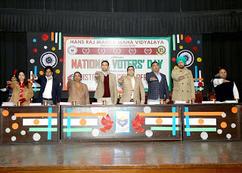
22 | A demonstration on fire fighting techniques by Department of Fire Brigade  Name –  fire fighting techniques  Collaborating agency –  NSS and NCC | Monday, 1 February 2021 | To help the students respond to the disaster situations, a demonstration on fire fighting techniques was held by Department of Fire Brigade in the college campus under the aegis of IQAC. The focused of the event was on the need to be prepared for the worst situations. such sessions help to put theory into practice and make the students aware of the techniques to protect themselves as well as others around, thus ensuring safety for all. | 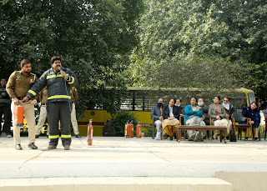  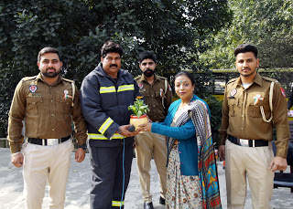
23 | Road Safety Month-2021  Name –  Road Safety Month-2021  Collaborating agency –  Youth and Sports Ministry of Government of India | Wednesday, 10 February 2021 | The NSS Unit of the college participated in Road Safety Month-2021. This is being organised by Youth and Sports Ministry of Government of India from 18th January to 17th February , 2021. The main theme of this campaign was “Road Safety, Life Safety”. The main objective of this campaign was to ensure the citizens about road safety. For this NSS Volunteers hold a awareness really outside the college campus. Principal of the college flagged off the road safety rally and encouraged all the volunteers. | 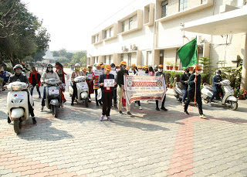  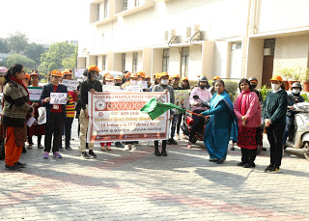
24 | Republic Day Camp  Name –  NCC Republic Day Camp  Collaborating agency –  NCC | Friday, 5 February 2021 | Km. Ravina, student of B.Sc. (Economics) Sem 5 of the college under 2PB (G) BN NCC, Jalandhar represented PHHP & Chandigarh. Directorate at the NCC Republic Day Camp held at New Delhi from December 20 to January 29, 2021. She was a part of Guard of Honour presented during PM Rally. | 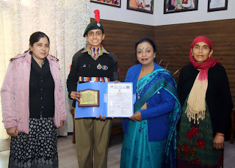
25 | A Webinar on “Importance of Citizen Feedback Form Swachh Sarvekhshan- 2021”  Name –  Importance of Citizen Feedback Form Swachh Sarvekhshan- 2021  Collaborating agency –  NSS | Saturday, 13 February 2021 | A Webinar on “Importance of Citizen Feedback Form Swachh Sarvekhshan- 2021” was successfully organized by the college with collaboration of Municipal Corporation Jalandhar. The dignitaries were Sh. Karmesh Sharma, IAS Commissioner, Municipal Corporation Jalandhar, S. Harcharan Singh, PCS, Joint Commissioner, Municipal Corporation Jalandhar, Sh. Dr. Puran Singh Yadav, Project Director, Swachh Bharat Mission, Punjab, Ms. Ramanpreet Kaur, CF & Programme Coordinator, SBM, (PMIDC) MCJ, Jalandhar. Everyone was encouraged to fill the Citizen Feedback form as it will enhance the contribution both qualitatively and quantitatively. | 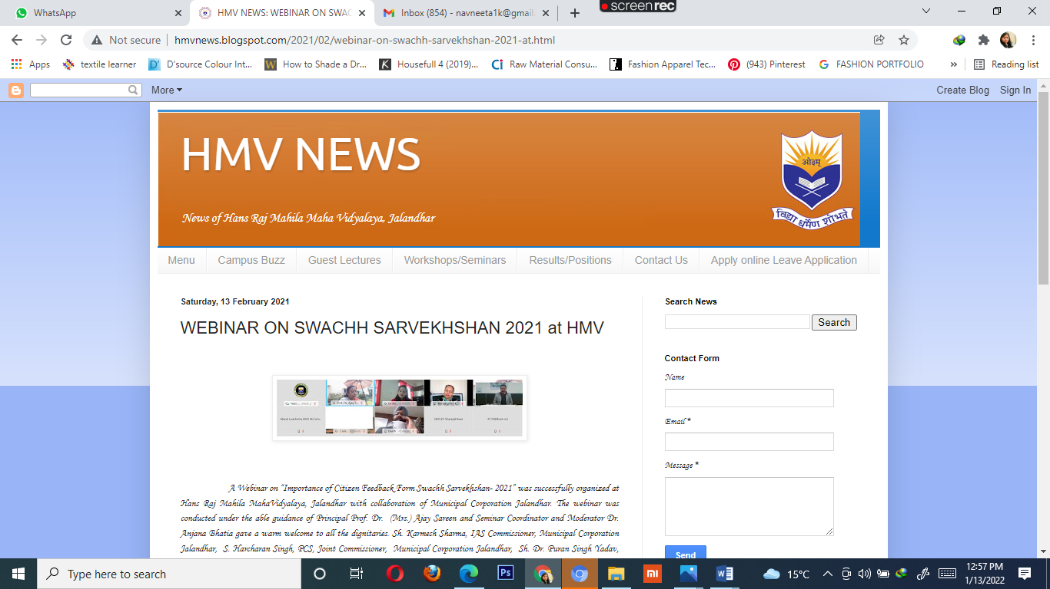
26 | Participation in Smart City Project of Municipal Corporation, Jalandhar  Name –  Smart City Project  Collaborating agency –  NSS & NCC | Thursday, 25 February 2021 | The NSS volunteers of the college participated in Smart City Project of Municipal Corporation, Jalandhar. On this occasion, Chief Minister Punjab Capt. Amrinder Singh inaugurated various projects under Smart City for the development of Jalandhar. From HMV Ms. Rashmi Sethi & Students Km. Ishpreet, Km. Riya, Km. Jagjeet Kaur, Km. Rupinder, Km. Manpreet and Km. Kashika performed as anchor and motivated every citizen of the city to contribute enthusiastically to make Jalandhar a Smart City. | 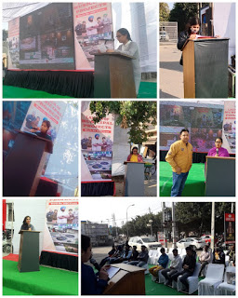
27 | An awareness Programme on ‘Plastic Free Environment’  Name –  Plastic Free Environment  Collaborating agency –  NSS & NCC | Tuesday, 23 March 2021 | An awareness Programme on ‘Plastic Free Environment’ was organized by Unnat Bharat Abhiyan Team of the college in Village Gillan. The UBA team urged the villagers to make the environment eco friendly by making it plastic free. Head, PG Department of Botany of the college and member UBA team apprised the people of village about the harmful effects of using the plastic. She explained that besides polluting the environment, it is dangerous for the animals also. When the plastic moves through the food chain, the toxins which are attached with it also move along. They were explained about the other alternatives instead of using plastic such as using cloth bags. The students of government school, Gillan, actively participated in the programme. They took a pledge that they will not use plastic and will even ask their family members to use other alternatives instead of plastic. | 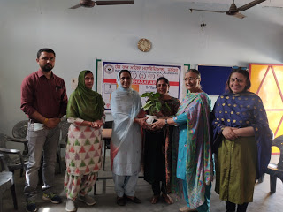
28 | Celebrated “Nutrition Fortnight” as per the guidelines of Ministry of Youth Programme & Sports.  Name –  Nutrition Fortnight  Collaborating agency –  NSS & NCC | Saturday, 3 April 2021 | College celebrated “Nutrition Fortnight” as per the guidelines of Ministry of Youth Programme & Sports. The objective of this programme was to highlight the importance of nutrition for better health. The NSS volunteers participated in Video Competition and tried to spread awareness regarding nutritious diet. Km. Gurvinder Kaur won first prize, Km. Ishpreet Kaur won second prize and Km. Harmanpreet Kaur won third prize. | 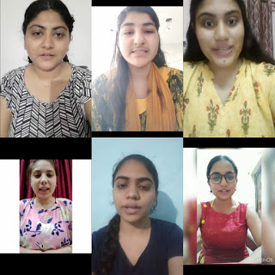
29 | Celebration of 75 years of Independence organized by NCC Group Headquarters, Jalandhar  Name –  75 years of Independence  Collaborating agency –  NSS | Monday, 12 April 2021 | ANO Lt. Sonia Mahindru and Army Wing Cadets of the college participated in celebration of 75 years of Independence organized by NCC Group Headquarters, Jalandhar. Group Commander Brig. Aditya Madan commemorates Shaheed Bhagat Singh’s bravery and courageous deeds in Indian freedom struggle. Cadets of 2 Pb. (G) BN NCC, Jalandhar paid homage to Shaheed-e-Azam Bhagat Singh by cleaning the statue at Bhagat Singh Chowk, Jalandhar. ANO Lt. Sonia Mahindru created awareness among cadets on saying “No To Plastic”. | 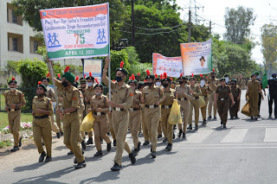  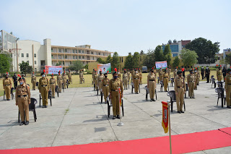
30 | Workshop on the Art of Living  Name –  how to handle stress and increase immunity for stress free teaching during Covid times  Collaborating agency –  Art of Living | Wednesday, 16 June 2021 | Hans Raj Mahila Maha Vidyalaya in collaboration with Art of Living organized workshop on how to handle stress and increase immunity for stress free teaching during Covid times. The Resource Person for the workshop was Dr. Minakshi Gupta, MD Gynae and Mr. Vivek Vansal from Art of Living. A practical session was taken by Dr. Minakshi Gupta where she emphasized upon the usage of Sudarshan Kriya that is quiet helpful to increase our immunity and is very essential for our daily life balance. She gave practical session on certain yoga Aasanas which is helpful in releasing stress. | 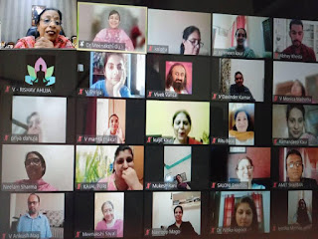
31 | Online workship on Beat COVID-Helpers Skills in association with Mahatma Gandhi National Council of Rural Education, Department of Higher Education, Ministry of Education, Govt. of India under the aegis of IIC, HMV  Name –  Beat COVID-Helpers Skills  Collaborating agency –  NSS, NCC, Student Council | Wednesday, 2 June 2021 | The NSS Unit organised an Online workship on Beat COVID-Helpers Skills in association with Mahatma Gandhi National Council of Rural Education, Department of Higher Education, Ministry of Education, Govt. of India under the aegis of IIC, HMV. The Resource Person was Mrs. Sandhya Tuti from MGNCRE, Ministry of Education, Govt. of India. She gave useful information on various teams like Medicine Team, Family Related Team, Communication with COVID Patient Team, Hospital Management Team etc. She also had an interactive session with NSS Volunteers. She educated the students through various case studies. This workshop was attended by NSS Volunteers, NCC Cadets and students of Student Council with full enthusiasm. | 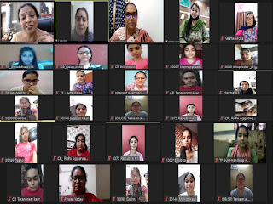
32 | Special vaccination camp for 2nd dose of vaccine  Name –  2nd dose of vaccine  Collaborating agency –  NSS, NCC, Student Council, local administration and Civil Hospital | Thursday, 27 May 2021 | A special vaccination camp for 2nd dose of vaccine was organised with the special permission of local administration and Civil Hospital. In this camp, 67 staff members of the college got vaccinated for 2nd dose of vaccine. Principal Prof. Dr. (Mrs.) Ajay Sareen appreciated the efforts of Dr. Seema Marwaha, Head of Zoology Department for organizing second camp in college premises. She said that HMV has always committed itself to safeguard humanity against the COVID virus by arranging first vaccination camp in the month of April. Now it is the 2nd phase of vaccination. Principal Dr. Sareen also thanked Civil Surgeon Jalandhar Dr. Balwant Singh, Dr. Rakesh Chopra DIO, Dr. Surbhi and their team members for the support given by them to make this camp successful. | 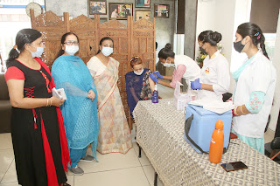
33 | Paid Vaccination Camp  Name –  Vaccination Camp  Collaborating agency –  District Administration, Jalandhar | Tuesday, 1 June 2021 | Paid Vaccination Camp by District Administration was started at Hans Raj Mahila Maha Vidyalaya, Jalandhar. The District Administration is offering Covaxin at nominal cost of Rs. 500/- to the general public. The camp was visited by Deputy Commissioner Sh. Ghanshyam Thori, IAS and SDM-I Sh. Jai Inder Singh. Around 100 people got vaccinated on first day. They pre-booked the slots of vaccination. Social distancing and other norms of COVID-19 are followed at vaccination centre. | 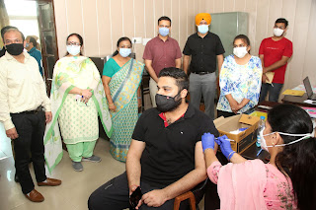
34 | Online Essay Writing Competition to observe World Telecommunication day  Name –  Essay Writing Competition - were Past, Present and Future of Telecommunication in India, Importance of Telecommunication in times of COVID- 19 and The Impact of Telecommunication on society.  Collaborating agency –  Chandrayaan Vipnet C lub | Saturday, 29 May 2021 | Chandrayaan Vipnet Club of PG Department of Physics organized Online Essay Writing Competition to observe World Telecommunication day. This day is celebrated to raise the awareness about the importance of communication in our lives through means of technology. Moreover, Corona Virus panedemic has highlighted the critical role of information and communication. The topics of the essay competition were Past, Present and Future of Telecommunication in India, Importance of Telecommunication in times of COVID- 19 and The Impact of Telecommunication on society. 70 Students from different institutes participated in the competition. Ms. Gauri Jindal B.Sc of HMV stood first, Mr. Bharat of Kurukshetra University and Ms. Ishpreet of HMV bagged second prize. Ms. Guninder Kaur from GNDU and Sakshi Sharma of HMV secured third prize. Consolation prize was tied between two students Ms. Vanshika from R.R.BAWA DAV College For Girls, Batala and Yashika Sood GNDU Amritsar. | 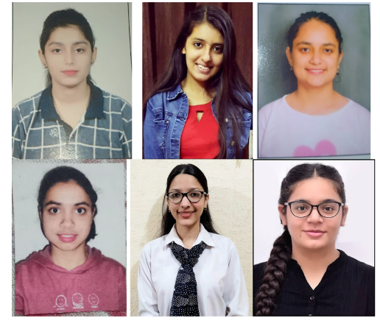
35 | International Day of Immunology by organizing a webinar on “COVID-19: Immune Response and Computational Resources”  Name –  COVID-19: Immune Response and Computational Resources  Collaborating agency –  ?? | Thursday, 29 April 2021 | Hans Raj Mahila Maha Vidyalaya celebrated International Day of Immunology by organizing a webinar on “COVID-19: Immune Response and Computational Resources”  The Resource Persons included an eminent scientist Prof. G.P.S. Raghava, Head Department of Computational Biology, Indraprastha Institute of Information Technology (IIIT), New Delhi and Dr. Deeksha (MD Pathology), Director Synergy Labs, Jalandhar. Prof. G.P.S Raghava explained the basics of vaccines, various types of vaccines, mechanisms involved in immune response to COVID-19 and pathway of vaccine discovery. He very well explained the multiple layers of the immune system and also showed how different features of the immune response can be used to develop computational tools and databases. It is worth mentioning that Prof. Raghava’s group has been the pioneer in developing a variety or web servers and software related to the field of immunology including the latest CoronaVIR. At the end of his talk he answered a variety of questions posted by the participants. Dr. Deeksha Chaudhary explained the evolution, structure and function of SARS CoV-2. She elaborated on various types of vaccines and their mechanism of action with special reference to a variety of COVID-19 vaccines being developed by various companies. | 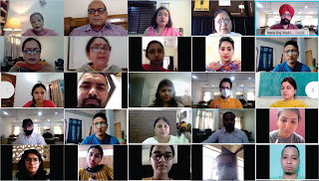
36 | International Yoga Day  Name –  International Yoga Day  Collaborating agency –  Ministry of Aayush, NCC, NSS and sportd dept. | Monday, 21 June 2021 | Hans Raj Mahila Maha Vidyalaya in collaboration with Ministry of Aayush celebrated International Yoga Day In this ceremony, the students of Student Council, NCC, NSS and Sports Department of the college along with teaching, non-teaching staff and supporting staff took part with full enthusiasm. Yoga Guru Mr. Dheeraj made the participants perform various Asans of Yoga. He said that in order to remain healthy and free from diseases, we should do yoga every day. | 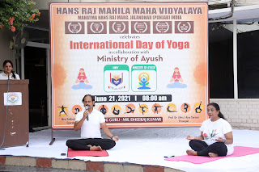
37 | Launch of e Sakhi App  Name –  e Sakhi App  Collaborating agency –  ??? | Thursday, 25 June 2020 | Hans Raj Mahila Maha Vidyalaya, Jalandhar has taken an initiative to connect to students during times of distress through e-sakhi app. The app was launched in January, 2020. During the times of Corona pandemic, many girl students may be facing anxiety, depression, stress and other mental health problems. The e-sakhi app is meant to extend a helping hand towards students sitting at home. Given the ubiquity of mobile devices, it made sense that help be provided through the mobile platform. So, through a special meeting, the mentoring incharges of the college guided the students about the emotional support available to them round the clock and at the click of just one button on their mobiles. The app was designed by Mr. Jagjit Bhatia, Associate Professor, PG Deptt of Computer Science and IT. He said that the app is very easy to download and operate and the student can get an immediate help from the mentor in case of any anguish or problem. Even if the student is feeling low, the app can help student connect with the mentor. The college also has DISHA counselling cell which is also providing e-counselling facilities during COVID-19. | 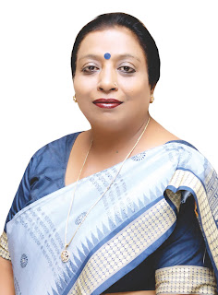
38 | webinar on “Woman Health Care  Name –  Woman Health Care  Collaborating agency –  The Red Ribban Club and Red Cross society | Saturday, 5 December 2020 | The Red Ribban Club and Red Cross society of Hans Raj Mahila Maha Vidyalaya, organized a webinar on “Woman Health Care”. Coordinator Red Ribban Club Mrs. Kuljit Kaur and Coordinator Red Cross Society Mrs. Deepshikha jointly organized this webinar in which Dr. Vimal Trikha was the Resource Person. She said that young generation girls are eating lack of nutritious food which is a matter of concern. She encouraged all the students to follow all the rules & take precautions during COVID-19. Dr. Trikha advised the girls to be physically, mentally & emotionally strong. She advised them to do exercise regularly, eat healthy food & do not think too much. Km. Gursimar Chaudhary told about the challenges for women in health care. Mrs. Kuljeet Kaur said that a woman can make a family healthy.. This webinar was attended by approximately 300 students. | 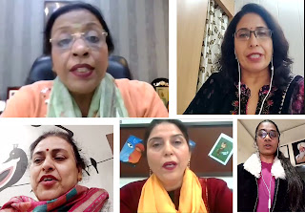
39 | e-poetry recitation competition  Name –  New Education Policy, Impact of COVID-19 on the Indian economy  Collaborating agency –  Planning Forum | Wednesday, 20 January 2021 | Planning Forum, the Subject Society of PG Department of Economics of Hans Raj Mahila Maha Vidyalaya organized an e-poetry recitation competition. The themes of the competition were related to current economic issues i.e. New Education Policy, Impact of COVID-19 on the Indian economy. Students participated enthusiastically in the competition and presented their views on various issues. Some of them also presented their self written poems. Rajveer Kaur, B.Sc. Computer Science Sem V, Ishpreet Kaur, BA Sem-V and Jyot Sifat Kaur, B.Com Financial Services Sem-III got first, second and third positions respectively. Judges of the competition Dr. Jyoti Gogia, Head, Hindi Department and Mrs. Kuljeet Kaur, Dean Holistic Development congratulated all the participants. | 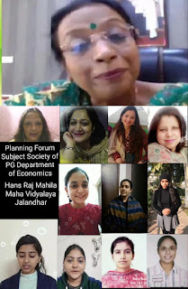
40 | International Women’s Day  Name –  New Education Policy, Impact of COVID-19 on the Indian economy  Collaborating agency –  Municipal Corporation, Jalandhar, Innovation Cell and Women Empowerment Cell | Monday, 8 March 2021 | International Women’s Day was organized in Hans Raj Mahila Maha Vidyalaya in collaboration with Municipal Corporation, Jalandhar under the aegis of Innovation Cell and Women Empowerment Cell. The dignitaries Sh. Karnesh Sharma, IAS Commissioner, Municipal Corporation Jalandhar, Mrs. Gurvinder K. Randhawa Joint Commissioner, Municipal Corporation Jalandhar, Dr. Kanwaldeep Kaur, Dean Academics, RJ Deepak, RJ Luveena, RJ Dheer were present on the occasion. Women should be given equal rights at every level as she possesses qualities of multi tasking, creating lives, taking pressures and she is a great care taker. She also facilitated the contribution of male counterparts due to which all women are able to do their jobs. Both men and women should be congratulated on this Women’s Day.  Sh. Karnesh Sharma IAS , Joint Commissioner Municipal Corporation Jalandhar said that it should be day of life. We should mark the contribution of women in society economically, politically and socially. Vision for women in past, present and future is marked. He appreciated the working of all sanitary inspectors and health workers of Municipal Corporation. He expects from institution that students should be made learn about human values and should be given opportunities. The society should be free from gender bias. All malpractices should be curbed from society. RJ Luveena, and RJ Dheer from 92.7 Big FM are associated with Swachh Survekshan 2021 . RJ Luveena gave the moto of “Love Yourself” and she insisted that Womens Day should be celebrated as “Ours Day”. RJ Dheer insisted that women should be respected from heart and he quoted examples like Rani Lakshmi Bai as exemplary women. He also made everyone pledge that we should keep our home, locality and city very clean . Some special prizes were also announced like Special Women Empowerment Award was given to Prof. Dr. (Mrs.) Ajay Sareen, Ms. Gurvinder K. Randhawa. Joint Commissioner, Municipal Corporation, Jalandhar, NSS Programme 41Officer Ms. Veena Arora and Ms. Harmanu Paul , Ms. Kuljit Kaur, Dean Holistic, Dr. Anjana Bhatia , Dr.Shri and Dr. Raj Kamal. On this occasion many health workers were honored with gifts, certificates and planters for their immense contribution in making the city clean. | 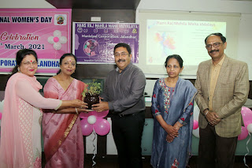
41 | Pledged to participate wholeheartedly against the COVID Pandemic.  Name –  Pledged to participate wholeheartedly against the COVID Pandemic.  Collaborating agency –  NSS, NCC and Student Council volunteers | Wednesday, 21 April 2021 | Under the able guidance of Principal Prof. Dr. (Mrs.) Ajay Sareen, the enthusiastic volunteers of Hans Raj Mahila Maha Vidyalaya, Jalandhar pledged to participate wholeheartedly against the COVID Pandemic. NSS, NCC and Student Council volunteers, Teaching and Non Teaching Staff took the pledge to render services for fight against Corona. | 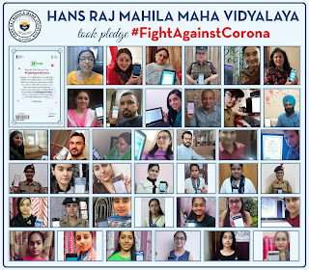
42 | National webinar on “Challenges and Opportunities in Water Management “  Name –  Challenges and Opportunities in Water Management  Collaborating agency –  Environment Club | Thursday, 3 December 2020 | To bring home the maxim that Water is the driving force of all nature, the Environment Club of Hans Raj Mahila Maha Vidyalaya organized a National webinar on “Challenges and Opportunities in Water Management” Sh Shiv Raman Gaur,IAS, Director Higher Education, DAV College Managing Committee as the Chief Guest and Dr. Rajendra Singh- the Waterman of India as the resource person of the webinar. They emphasized that water is the elixir of life and water conservation movement initiated by Padam Shree Dr. Punam Suri, President, DAV College Managing Committee was a step towards this direction.  Raising the slogan, ‘Jal hai to kal hai’, Sh. Shiv Raman Gaur pointed out the alarming facts about the decreasing levels of water table. He stressed that no doubt we are very vocal about the problem but we lack initiatives on our part to put theory into practice. He said that we should inculcate the habit of saving water and follow it in our daily routine. These small steps can make a big difference. He appealed to the students to take care of the mother nature as she has the cure to all our diseases. | 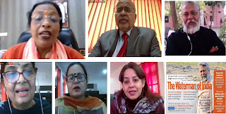
43 | A one week online Workshop by Art of Living organization on How to maintain Harmony in Corona times and How to become a successful leader  Name –  How to maintain Harmony in Corona times and How to become a successful leader  Collaborating agency –  science Club and commerce club | Thursday, 24 September 2020 | A one week online Workshop by Art of Living organization on How to maintain Harmony in Corona times and How to become a successful leader was inaugurated at Hans Raj Mahila Maha Vidyalaya, Jalandhar. The workshop was conducted by the Madam Vashali Punj, facilitator of Art of Living. Ms Vaishali apprised the students about techniques of coping with mental stress with light practical exercises. The first sessions were attended by students and teachers of science and commerce classes. In the upcoming sessions, the students of Humanities group will take the online sessions. | 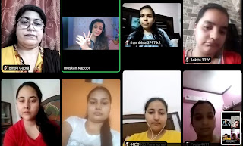
44 | A one week online Workshop by Art of Living organization on How to maintain Harmony in Corona times and How to become a successful leader  Name –  How to maintain Harmony in Corona times and How to become a successful leader  Collaborating agency –  Ministry of Information and Broadcasting, Government of India | Saturday, 19 September 2020 | The faculty members and students of Psychology department of Hans Raj Mahila Maha Vidyalaya participated in a webinar organized by Ministry of Information and Broadcasting, Government of India. The topic of the webinar was “Mental Health and Enhancing Immunity in times of COVID-19. This webinar was jointly organized by Press Information Bureau and Regional Outreach Bureau, Chandigarh, Ministry of Infomation and Broadcasting, Government of India. Around 20 students of Psychology department of HMV along with the faculty members participated in this webinar. Mr. Ashish Goyal, Director (North-West Region), Ministry of Information and Broadcasting, Government of India welcomed the participants and highlighted various initiatives taken by the Government of India to address issues related to mental health and enhancing immunity in times of COVID-19. Dr. Arun Bhardwaj, a motivational speaker told the students that physical fitness and mental fitness are basic foundations of living a happy life. They were also told about the basic ayurvedic remedies to enhance their immunity level especially in time of pandemic. | 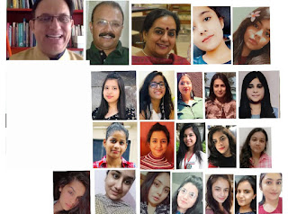
45 | Green Diwali - Online competitive events such as Decorative Diya, Rangoli, Decorative plant and Greeting card with slogan were organized.  Name – Green Diwali  Collaborating agency –  Zoology and Environment Club | Friday, 13 November 2020 | Zoology and Environment Club celebrated Green Diwali. Online competitive events such as Decorative Diya, Rangoli, Decorative plant and Greeting card with slogan were organized. Around 100 students of all streams enthusiastically participated in the event. Principal, Dr. (Mrs.) Ajay Sareen, congratulated Environment Club for taking the initiative of celebrating Green Diwali. She further gave the message of pitching for ‘Vocal for Local’ and celebrating a ‘Swadeshi Diwali’. She concluded by saying that this Diwali, we must make an endeavor to bring smiles on everyone’s face. Dr. Seema Marwaha, Head of Zoology Department and coordinator of Environment Club explained about the initiative of celebrating Green Diwali taken by the Environment Club which is the practice of this Club for the past many years. The Club also organizes awareness campaign including celebration of Organic Holi, Eco-friendly Rakhi, minimizing use of plastic and other measures for Environment Conservation and Sustainable Development. | 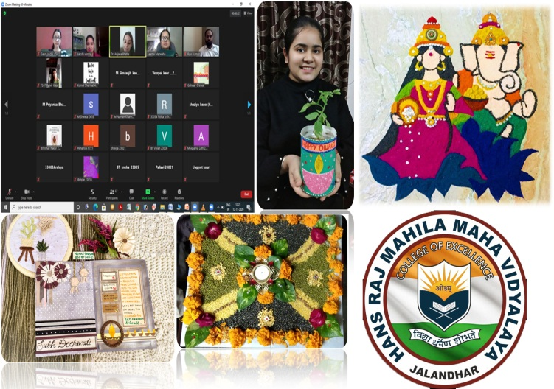
46 | Eco Friendly Holi  Name –  Eco Friendly Holi  Collaborating agency –  Environment Club | Monday, 9 March 2020 | Environment Club prepared organic colours from beetroot, turmeric, spinach, hibiscus and gramflour. The staff and students imprinted the colours on banners with a prayer of safety and health of all the life forms on Earth. While imprinting her colour filled hand on the banner, Principal Dr Sareen also urged upon the students to avoid Mass Gatherings and stay safe during this "festival of colours" and work upon repairing broken relationships. Incharge of environment Club, Dr Seema Marwaha said that all festivals should be celebrated in an eco-friendly manner. Dr Anjana Bhatia said that this year we should skip the traditional way of celebrating Holi – one with water balloons, pichkaris and toxic colours that end up taking a huge toll on the environment and health and instead we should focus on spreding positive vibrance using dry flowers or leaves, turmeric, chandan and henna and stay protected. | 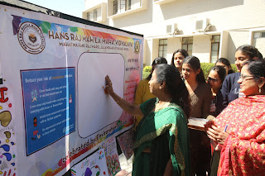  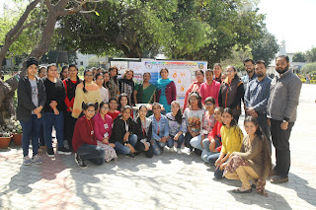
47 | "Vrikshabandhan"  Name –  "Vrikshabandhan"  Collaborating agency –  Innovation Cell, Environment Club & Student Council | Saturday, 21 August 2021 | Carrying on with its tradition, Hans Raj Mahila Maha Vidyalaya celebrated the indigenous festival of Rakshabandhan with a difference. Innovation Cell, Environment Club & Student Council celebrated the festival as "Vrikshabandhan". On this Occasion Dr Sushma Chawla was the chief guest and Ms. Ramanpreet was the guest of honour. Sharing the concept of Vrikshabandhan. The students tied threads to trees & pledged to take care of them. This initiative of HMV is much appreciated by MGNCRE, Ministry of education and this year MGNCRE has also taken the initiative of celebrating Rakshabandhan as Vriksh Raksha Bandhan. Rakhi Sakhi was also organized. Dr Anjana Bhatia, Dean Innovations and Research said that the students have further saved the environment by making organic handmade rakhis. | 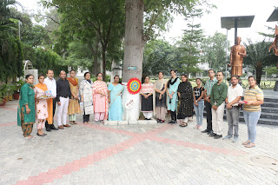
48 | 95th Foundation Day  Name –  95th Foundation Day  Collaborating agency –  Whole college???? | Friday, 9 April 2021 | With a sense of rare pride, honour and cheerful exuberance Hans Raj Mahila Maha Vidyalaya hold 2nd day of its three days celebrations to mark the occasion of its 95th Foundation Day. First day saw the launching of IIC Web Page and plantation of medicinal herbs continuing the celebrations the second day started with Havan Yajna with Joint Commissionar, Municipal Corporation, Jalandhar S. Harcharan Singh as chief guest, Ms. Beenu Rajput, Director of documentary films and Govt. of India’s Ambassador for Fit India Movement. Mrs. Vani Vij, Director Dainik Savera, Dr. Pawan Gupta, Mr. Ashok Pruthi and Mr. S.P. Sahdev members of Local Committee also graced the vedic prayer. S. Harcharan Singh, Joint Commissioner, in his presidential remarks, praised the college for dispensing its social duties excellently and for making its students empowered women to lead the society successfully. HMV alumnae Ms. Beenu Rajput renowned Filmmaker of Delhi has been selected as “Fit India Ambassador” and “Fit India Champion”, in Sports Authority of India and under her banner Beenu Rajput Films, she organized Ist Run for Lives 2021 in collaboration with HMV to promote fitness in daily routine. An e-app of Biodiversity which has the digital data of all plantation of our college was also launched with the joint efforts of Botany and Computer Department Mr. Jagjit Bhatia, Dr. Anjana Bhatia. HMV’s Mass Communication department launched its Internet Radio “Awaaz”. The launching was done by legendary Punjabi Singer Mr. Firoz Khan. He appreciated the efforts of the college & department and encouraged the faculty to achieve higher in the field of Radio. | 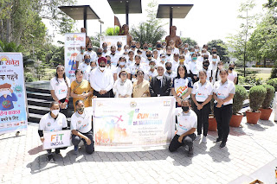
49 | Tree Plantation Drive  Name –  Tree Plantation Drive  Collaborating agency –  DD Pant Botanical Society, Rotary Club of Jalandhar City Youth | Saturday, 24 July 2021 | DD Pant Botanical Society of Post Graduate Department of Botany organized a Tree Plantation Drive to create enthusiasm and awareness amongst the masses for increasing the green cover of our nation. The tree plantation drive was carried out in collaboration with Rotary Club of Jalandhar City Youth. Rtr Ranveer Singh President, Rtr Srishti Sidana Secretary, Rtr Manan Verma Project Director, Rtr Ankush Co-Project Director, Rts Simran Sadana Supervisor, Rtr Nandini, Rtr Ritik, Rtr Sarabjit Singh and Rtr Samar Rathore helped in the tree plantation drive. 100 plants of indigenous trees like Kachnar, Putranjeevak, Papaya, Mango, Guava, Cassia were planted by the faculty members of HMV. | 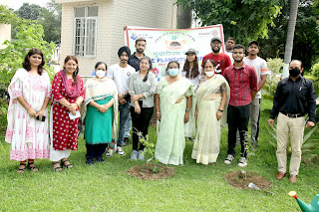
50 | Rishi Bodh Utsav  Name –  Rishi Bodh Utsav  Collaborating agency –  Student Council | Monday, 24 February 2020 | Student Council celebrated Rishi Bodh Utsav. A melodious Bhajan was presented by the students of Music department and a beautiful speech on the teachings of Swami Dayanand Saraswati ji was delivered by Mansi Laochotra, Asst. Head girl of the college, which enlightened the students and staff members and encouraged them to follow the precious teachings of Swami Dayanand Saraswati ji. | 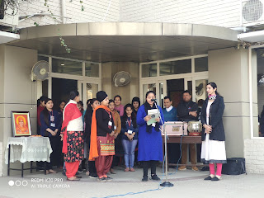
51 | Dhiyan Di Lohri  Name –  Dhiyan Di Lohri  Collaborating agency –  Student Council | Saturday, 16 January 2021 | HMV Hostel celebrated “Dhiyan Di Lohri” with full enthusiasm. The motive of this festival was to upgrade the position of women in society. The students presented cultural progarmme on this occasion.  Principal Prof. Dr. (Mrs.) Ajay Sareen congratulated all the hostelers on the occasion of Lohri and said that HMV is always working towards women empowerment. This institution has always stressed on the need of holistic growth of women & will continue to do so. Many girls are working on respectable positions in society who are the alumnae of this great institution.  Mrs. Meenakshi Syal (Coordinator Resident Scholar) also addressed the students and told them about the historical aspect of this festival. She said that this festival is a symbol of bravery & truth. She said that main motive behind celebrating Dhiyan Di Lohri is to inculcate such qualities in them so that they can change the thinking of society towards them. | 